STRUCTURAL IRON WORKERS
LOCAL NO. 1 WELFARE FUND

STATEMENT OF EMPLOYER

Disability Claim
Administered by:
Group Administrators, Ltd
953 American Ln, Suite 100, Schaumburg, IL 60173
Employee’s Name |  |  |  | I.D. No. Unit or Div. No.
Date By / / |  | Title |  | Telephone # ( ) ―
(Signature)  INSTRUCTIONS TO EMPLOYEE |  |  |  | Area Code
(1)  (2) | This form is to be filed as soon as it appears that you will qualify for disability benefits.  Complete the Statement Of Employee and the Authorization For Release Of Information below. | (3)  (4) |  | Have your physician complete the Attending Physician’s Statement on the reverse side.  Return Form to Group Administrators, Ltd. (see address above)
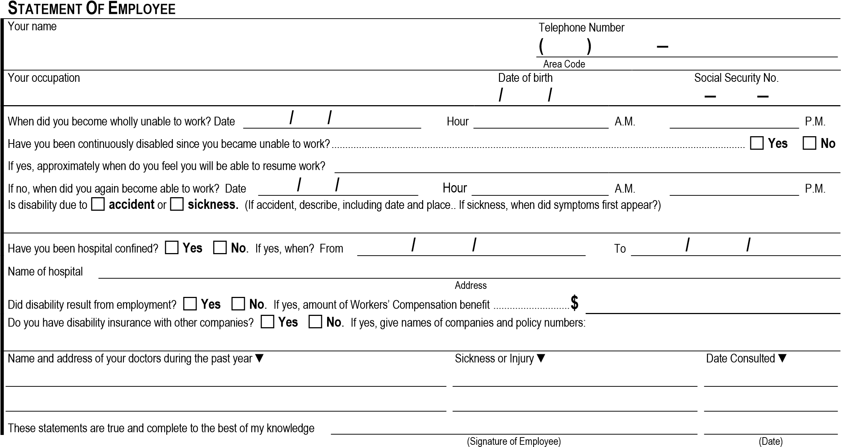
STATEMENT OF EMPLOYEE
In order to process a claim for benefits, I authorize any physician, hospital or other medical provider to release to Group Administrators, Ltd., or its representative, any information regarding my medical history, symptoms, treatment, examination results or diagnosis. A photocopy of this authorization shall be considered as effective and valid as the original. This authorization shall be considered valid for the duration of the claim, but not to exceed one year from the date signed. I understand I have the right to receive a copy of this authorization.
Date Signature of Employee

_{Address of Employee}
Street City State Zip Code
Is this a new address? |  | Yes |  | No

DISABILITY CLAIM
ATTENDING PHYSICIAN’S STATEMENT
1. HISTORY
(
a)
Mo.
When did symptoms first appear or accident happen?.....................................................
Day
Year
(
b)
Mo.
Date patient ceased work because of disability?...............................................................
Day
Year
(
c)
Has patient ever had same or similar condition?...............................................................

Yes
No
If “Yes” state when and describe

d)
(
Is condition due to injury or sickness arising out of patient’s employment?......................

Yes
No
Unknown

(
e)
Names and addresses of other treating physicians...........................................................

2
.
DIAGNOSIS
(
a)
Diagnosis (including any complications)

- Subjective symptoms

- Objective findings (including current X-rays, EKG’s, Laboratory Data and any clinical findings

3
.
DATES OF TREATMENT
Mo.
Date of first visit..................................................................................................................
(
a)

Day

Year

Mo.
Date of last visit..................................................................................................................
b)
(

Day

Year

Frequency..........................................................................................................................
c)
(
Weekly
Monthly
Other

(
Specify
)

NATURE OF TREATMENT
4
.
(
Including Surgery and medications prescribed, if any)

.
PROGRESS
5
(
Has patient...................................................................................................
a)
Recovered
Improved
Unchanged
Retrogressed

Is patient.......................................................................................................
b)
(
Ambulatory
House confined

Bed confined
Hospital confined
(
c)
Has patient been hospital confined?
Yes

No
If yes, give Name and Address of Hospital

Confined from

/
/
through

/
/
CARDIAC (If Applicable)
.
6
(
a)
Functional capacity......................................................................................
Class 1
No limitation
)
(

Class 2
(
)
Slight limitation

(
American Heart Association
)......................................................................

Class 3

Marked limitation
)
(

Class 4
(
)
Complete limitation

Blood Pressure (last visit)..............................................................................
b)
(

/

SYSTOLIC
DIASTOLIC

PROGNOSIS
.
7
ANY OTHER WORK
PATIENT’S JOB
Is patient now totally disabled?...................................................................................................
a)
(

Yes
No
Yes
No
incapable
What duties of patient’s job is he/she
b)
(
of performing?

(
c)
Do you expect a fundamental or marked change in the future?................................................

Yes
No
Yes
No
If yes, when will/or did patient recover sufficiently to perform duties?.......................................
d)
(

/
/

/
/

1 mo.
3-6 mo.
1 mo.
3-6 mo.
Remarks

1-3 mo.
Never
1-3 mo.
Never
REHABILITATION
8
.
(
a)
Is patient a suitable candidate for further rehabilitation services? (i.e., cardiopulmonary program, speech therapy, etc.)...............................................
Yes
No
(
b)
Can present job be modified to allow for handling with impairment?.................................................................................................................................

Yes
No

PATIENT’S JOB

ANY OTHER WORK
(
c)
When could trial employment commence?.........................

/
/

Full-time

/
/

Full-time

Mo.
Day
Yr.

Part-time
Mo.
Day
Yr.
Part-time
(d) | Would vocational counseling and/or retraining be recommended? |  | Yes |  | No
 |  |  |  |  |  | ( ) | ―
PRINT Physician’s Name Degree Specialty Telephone

Street Address
City
State or Province
Zip Code
Date

/
/
Signature

Tax Identification Number

